THIS COMMUNICATION IS MEANT FOR ALL OFFSHORE EMPLOYEES GLOBALLY WHO RECEIVED SALARY IN INDIA PAYROLL FOR THE PERIOD 01 APRIL 2020 TO 31 MARCH 2021

Dear Colleagues,

We are providing digitally signed Form 16 for the Financial Year 2020-2021. Form-16 is getting issued in three parts, Part-A, Part-B and Annexure to Part-B.

Part-A: This is downloaded from Income Tax Department’s Portal called TDS Reconciliation Analysis and Correction Enabling System or TRACES.

Name and address appearing in Part-A is as per your records with Income Tax Department. For any discrepancy, you need to get it rectified directly from IT Department.

Part-B:There is change from last year onwards, the Part-B, also getting downloaded from Income Tax Department’s Portal called TDS Reconciliation Analysis and Correction Enabling System or TRACES.

Annexure to Part-B : This will be having the bifurcation, if any 2 (f), 10(k), Form 12BA and summary of components break-ups, as per HCLT payroll system records.

The below mentioned attachments will be sent to you in email.
- Form 16 Part-A (downloaded from TRACES Portal and digitally signed)provided tax has been deducted from your salary during financial year,
- Form 16 Part-B (downloaded from TRACES Portal and digitally signed).
- Annexure to Part-B (downloaded from HCLT payroll system records).
- Form 16 Instructions 2020-21(word document).

Form16 Part-A, Part-B and Annexure to Part-B will also be uploaded in ESS page of
myhcl.com latest by 31th July 2021.

For any queries related to Form 16, please raise SSD under SSD under EHS (Employee Services)→ Taxation Process→ Form 16.

For separated employees, Form 16 (Part-A, Part-B and Annexure to Part-B) will be sent to their personal mail id’s (updated at the time of leaving organization)directly. Form 16 of separated employees will also be available at the Separation portal.

Continued….

FAQ’s for Digitally Signed Form 16 are provided below: -

Q1: What is the meaning of digital signature?
A1: A digital signature is an electronic signature that can be used to authenticate the identity of the sender of a message or the signer of a document, and to ensure that the original content of the message or document that has been sent is unchanged. Digital signatures take the concept of traditional paper-based signing and turn it into an electronic "fingerprint.” This "fingerprint,” or coded message, is unique to both the document and the signer and binds both together.
“Digital Signature" means authentication of any electronic record by a subscriber by means of an electronic method or procedure in accordance with the provisions of Information Technology Act 2000.

Annexure to Form 16 in Part-B will not carry the digital signature.

Q2: Are physical signatures not required in Form 16?
A2: Both handwritten and digital signatures (standard electronic signatures) are legally-binding, Digital signatures ensure non-repudiation of documents. For example, any changes made to an electronically signed document are clearly indicated and will immediately invalidate the signature, thereby protecting against forgery/ unauthorized modification.

Q3: In case I need duplicate copies, how will I get them?
A3: The Form16 will be available in myhcl.com, you can print copies anytime.

Q4: If the Form 16 is required by banks, what should I do?
A4: Form 16’s could be forwarded to the banks electronically in emails.

Q5.Should I attach my Form 16 with income tax return.
A5. For the filing of Income Tax Return, it is not required to submit the Form 16 Physical
copies. If the assessing officer asks for a copy you can submit Form 16.
Part-A and Part-B and Form12BA. Form 16 Annexure is for your information only.

Q6: How do I check the authenticity of digital signature?
A6: Please see below the steps for digital signature validation

Continued….

Procedure for validating digital signature:

- Click on digital signature in your Form 16 (Part-A and Part-B). Please note the validation process required to be done only once. Next time when you open form 16 on top of the screen you can see the header certified by Sunil Idnani…in signature panel indicating it is already validated.

Right click on the signature appearing in your form 16 as below and choose validate signature

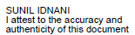

- Click on the tab "Signature Properties" as below:

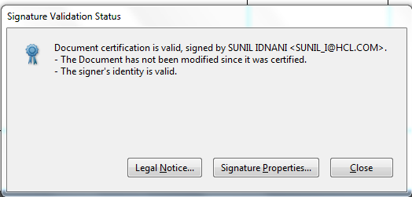

Contd…

- Click on the tab “Show signers Certificate”

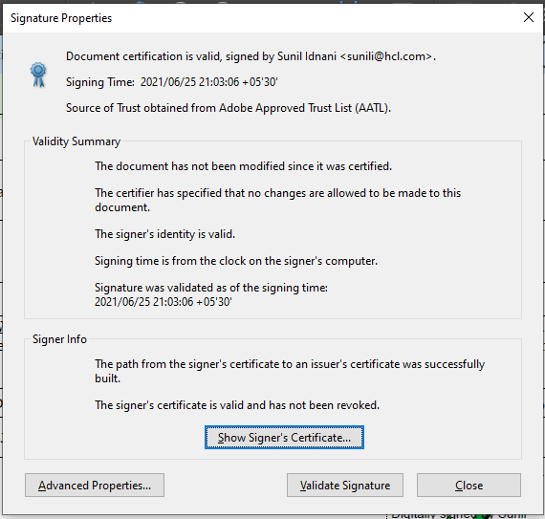

Depending on Adobe version screenshots 2 and 3 may vary. Click on the boxes in your screen with names like the screenshot here to proceed further.

Contd..

- Click on the tab “Trust”

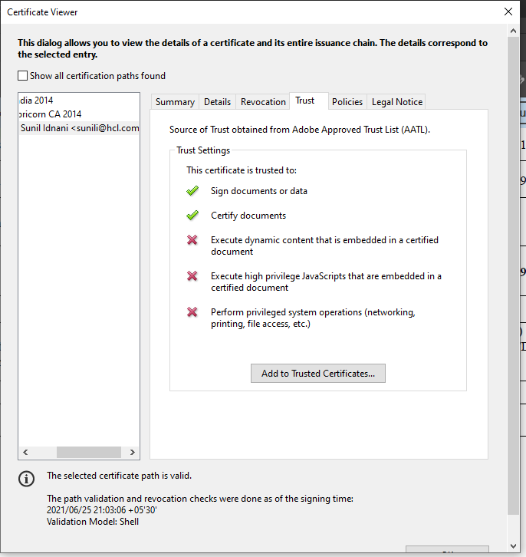

- Click on “Add to Trusted Identities”-

Please note that the button Add to Trusted entities will be enabled only during the first time you validate the signature. Thereafter it will be disabled

Contd……

- Click “OK”
In some Adobe versions this step/screen is not available

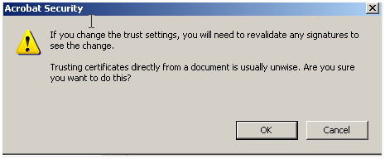

- Click “OK”

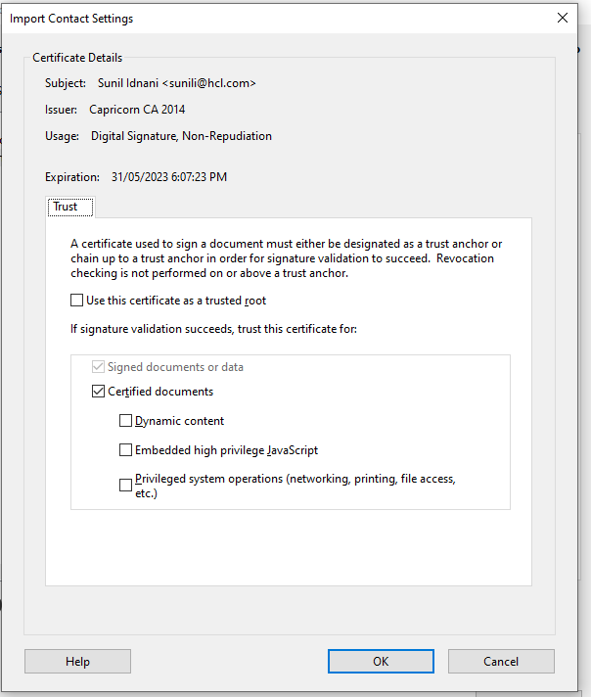

Contd……

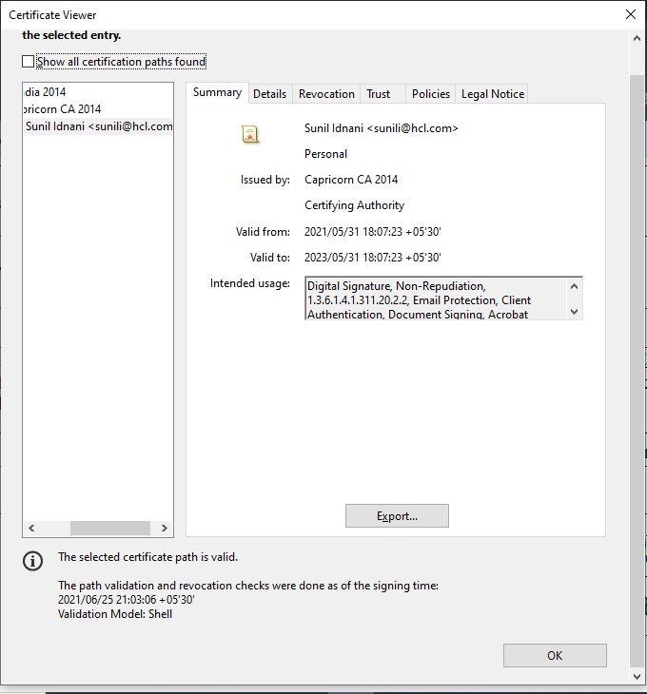

Contd……

8) Click on the tab “Validate Signature”
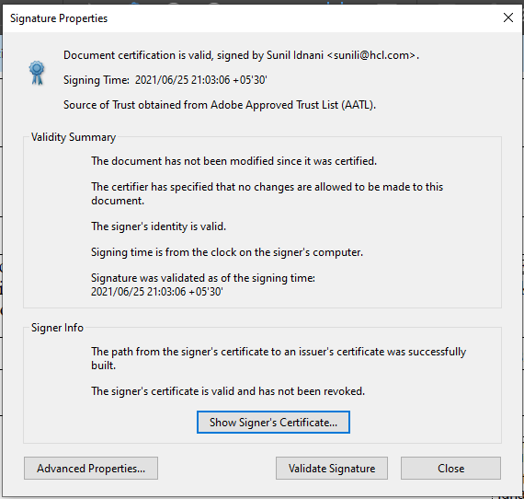

See the Note on top of screenshot above (Signature Properties) where blue icon is appearing in signature panel showing that the signature is valid

Contd….

General Information:

Income Tax Return changes for FY 2020-21 (AY 2020-21),applicable to Employees:-
- The last date for filing of IT return is 30thSeptember2021 as per the information available at the time of sending this document.
- Quoting of Aadhaar Number/Aadhaar Enrolment ID is mandatory.
- ITR-1 is to be filed by an assessee having total income below Rs50 lakh. ITR-2 needs to be e-filed in case total income is greater than that or equal to Rs50 lakh.
- ITR-3 and ITR-4 (to be filed by contract employees) as applicable.
- Specific column has been given for “Long term capital gain from Equity Share” and “Dividend income from Indian Company” under “Exempt Income” Schedule in ITR-1. This is apart from “Agricultural Income”
- Need to report separately where dividend income from Indian Company exceeds Rs10 lakh under “Other Income” Schedule. (Applicable from ITR-2 onwards). Same is the case with “Exempt Income” schedule.
- Changes have been made in “Schedule AL” regarding the following: -
Immovable Property: - Need to mention description along with address of the property.
Additional field added: - Insurance Policies – Amount(Rs)
Interest held in assets of a Firm or Association – Name, Address and PAN of the Firm or Association.
Note: - “Schedule AL” is applicable in case where total income exceeds Rs 50 lakh)
- Need to mention the amount on which TDS deduction has been made by the deductor along with TDS amount. This is applicable for ITR-1 and ITR-4 (Presumptive Income)

Tax Amendments applicable for FY 2020-21 (AY 2021-22):-

- Introduction of section 115 BAC ‘New Tax Regime’ from financial year 2020-21 (AY 2021-22): This section provides that on fulfilment of certain conditions (without any exemptions and deductions), an individual shall have the option to pay tax in respect of the total income at following rates:

Up to Rs 2,50,000per annum | Nil
From 2,50,001 to 5,00,000per annum | 5 %
From 5,00,001 to 7,50,000per annum | 10 %
From 7,50,001 to 10,00,000per annum | 15 %
From 10,00,001 to 12,50,000per annum | 20 %
From 12,50,001 to 15,00,000per annum | 25 %
Above 15,00,000per annum | 30 %

- In the ‘Old Tax Regime’ : The existing tax slabs continue as below :

Up to Rs 2,50,000per annum | Nil
From 2,50,001 to 5,00,000per annum | 5 %
From 5,00,001 to 10,00,000per annum | 20 %
Above 10,00,000per annum | 30 %

- Basic Exemption Limit: - No change in Basic Exemption limit. Basic Exemption Limit for individual is Rs.2.5 Lakh, for Senior Citizen is Rs.3 Lakh and for Super Senior Citizen is Rs.5 Lakh.
- Rebate u/s 87A:- Amount of rebate is up to Rs12500 (applicable to resident individual having total income up to Rs 5.0 lakh).
- Deduction with respect to Interest on loan taken for Residential Property (Section 80EE):- Deduction up to Rs50000 on fulfillment of below conditions:-
- Loan from Bank/Housing Finance Company is taken for acquisition of residential house property.
- Loan has been sanctioned by the bank/ Housing finance company during 1stApril, 2016 to 31st March 2017.
- The amount of loan sanctioned for residential house property does not exceed Rs 35 Lakh.
- The value of the residential house property does not exceed Rs 50 lakh.
- The assesse does not own any residential house property on the date of sanction of loan.

- Section 80EEA – Deduction for interest paid on home loan for affordable housing.

- Housing loan must be taken from a financial institution or a housing finance company for buying a residential house property.
- Stamp duty value of the house property should be Rs 45 lakhs or less.
- The individual taxpayer should not be eligible to claim deduction under the existing Section 80EE.
- The taxpayer should be a first-time home buyer. The taxpayer should not own any residential house property as on the date of sanction of the loan.
- Conditions with respect to the carpet area of the house property. These conditions have been specified in the memorandum to the finance bill, but not mentioned in section 80EEA:Carpet area of the house property should not exceed 60 square meter ( 645 sq ft) in metropolitan cities of Bengaluru, Chennai, Delhi National Capital Region (limited to Delhi, Noida, Greater Noida, Ghaziabad, Gurgaon, Faridabad), Hyderabad, Kolkata and Mumbai (whole of Mumbai Metropolitan Region), Carpet area should not exceed 90 square meter (968 sq ft) in any other cities or towns.
- Further, this definition will be effective for affordable real estate projects approved on or after 1 September 2019

- Section 80EEB – Deduction in respect of interest paid on loan taken for the purchase of electric vehicle
- A deduction for interest payments up to Rs 1,50,000 is available under Section 80EEB. An individual taxpayer may have an electric vehicle for personal use or for business use.

- The loan must be taken from a financial institution or a non-banking financial company for buying an electric vehicle.

Contd…

- The loan must be sanctioned anytime during the period starting from 1 April 2019 till 31 March 2020.

- “Electric vehicle” has been defined to mean a vehicle which is powered exclusively by an electric motor whose traction energy is supplied exclusively by traction battery installed in the vehicle and has such electric regenerative braking system, which during braking provides for the conversion of vehicle kinetic energy into electrical energy.

- Withdrawal of amount from New Pension Scheme: - The amount standing to the credit of the assesse for which a deduction has already been claimed, received by an assesse on closure of account or his opting out of NPS Scheme is taxable to the extent of 60%. Further provided that, if an amount received by a nominee on the death of the assesse then whole amount will be exempt from tax.

- Holding period in case of Unlisted Shares: - Holding period of unlisted shares (equity or preference share) has been reduced from 36 months to 24 months to qualify for short term capital asset.

- Belated return u/s 139(4):- The assesse can furnish the return of any previous year till the end of relevant assessment year. Earlier it was before the expiry of one year from the relevant assessment year. For e.g. return for financial year 2017-18 can be filed till 31st March 2019.

In the 2018 Budget announcement relating to a new section, 234F has been announced by the Government. Section 234F will be applicable for returns filed for the financial year 2017 – 18 onwards A penalty of Rs.5000 will be applicable for returns filed after the due date of 30thSept. but before 31st December of the relevant assessment year. In case an income tax return is filed after 31st December, a penalty of Rs. 10,000 will be applicable. For assesses with a taxable income of up to Rs. 500,000, a reduced penalty of Rs.1000 will be applicable.

- Advance tax installment: - The assesse is required to pay advance tax in four installments i.e. 15 %( on and before 15th June), 45% (on and before 15 September), 75% (on and before 15 December) and 100% (on and before 15 March). For assessee having presumptive income u/s 44AD or 44ADA (1) is required to pay 100% advance tax till 15 March.

- TDS on “Payment of accumulated balance due to an employee” u/s 192A:- Threshold limit is increased from Rs. 30,000 to Rs. 50,000 with effect from 1st June 2016.

- Deduction in respect of rent paid (Section 80GG):- Threshold limit is increased from Rs. 24,000 to Rs. 60,000.

- Standard deduction under section 16(i)a of Rs 50000.00 is available and medical reimbursement up to the limit of 15000.00 and transport allowance Rs 19200.00 is removed from the FY 2018-19 (AY 2019-20)

Warm Regards,
FSS - ES Team

